Original scientific paper *

TITLE OF PAPER (style heading 1: font formats - times new roman, 12 pt bold, ALL CAPS; paragraph formats: centered, spacing before 30 pt, spacing after 0 pt, keep with next, KEEP LINES TOGETHER)

Name Surname¹, Name Surname², … (Style Heading 2: 10pt bold, title case, centered, spacing before 0 pt, spacing after 12 pt, keep with next, keep lines together; write full name and full surname)

¹Affiliation (Style Affiliation: 10pt, centered, spacing before 0 pt, after 18 pt, keep with next; only affiliation, no postal address, no email-address)
²Affiliation (Style Affiliation; only if affiliation differs; use superscript only if needed)
Abstract. Short abstract (Style Abstract: 9 pt, italic, pt, justified, 0.75 pt left and right indentation).
Key words: Key word 1, Key word 2... to (max) Key word 6, min 4

1. Main Heading (Style Heading 3: Small Caps 10 pt, Centered, Spacing Before 24 pt, Spacing After 6 pt, Keep With Next, Keep Lines Together)
Important: The predefined styles are to be used. All parts of the manuscript (title, authors, affiliations, abstract, keywords, subtitles, text, figures, figure titles, tables, table titles, equations, references, etc.) must use the suitable style. The styles are described here, but they are available in this file, in the list of styles. The styles define the spacing to surrounding manuscript elements (before and after) and, hence, empty lines should not be inserted. The authors should be aware that the failure to use the proper styles and therewith to properly format the manuscript would postpone processing of the submission.
Main text: use only characters and symbols available in the Times New Roman or Symbol font, 10 pt; paragraph format: justified alignment, left and right indent 0 pt, space before and after 0 pt, first line indent 0.5 cm. First line of the paragraph should be indented 0.5 cm. An Equation Editor is to be used in the main text only if symbols are needed (when explaining terms from equations, for instance) that are not available as plain text or symbols.

1.1 Subheading (Style Heading 4: 10 pt, bold, left, indentation left 5 pt,
spacing before 12 pt, after 6 pt, keep with next, keep lines together)
Sample of main text. Sample of main text. Sample of main text. Sample of main text. Sample of main text. Sample of main text. Sample of main text. Sample of main text. Sample of main text. Sample of main text. Sample of main text. Sample of main text. Sample of main text. Sample of main text. Sample of main text. Sample of main text. Sample of main text. Sample of main text. Sample of main text. Sample of main text. Sample of main text. Sample of main text. Sample of main text. Sample of main text.

1.1.1 Subheading (Style Heading 5: 10 pt, italic, left, indentation left 5 pt,
spacing before 12 pt, after 6pt, keep with next, keep lines together)
Sample of main text. Sample of main text. Sample of main text. Sample of main text. Sample of main text. Sample of main text. Sample of main text. Sample of main text. Sample of main text. Sample of main text. Sample of main text. Sample of main text.
Equations should be prepared using the Insert Equation Editor with integrated styles (Cambria Math) and 10 pt size with Display centered format and 6pt befor and after spacing. Important: The authors should use an Equation Editor (inline form) directly in the text (e.g. when they explain terms/quantities used in the equations). For symbols ($ϖ ξ Σ$) Editor equation should be used too.
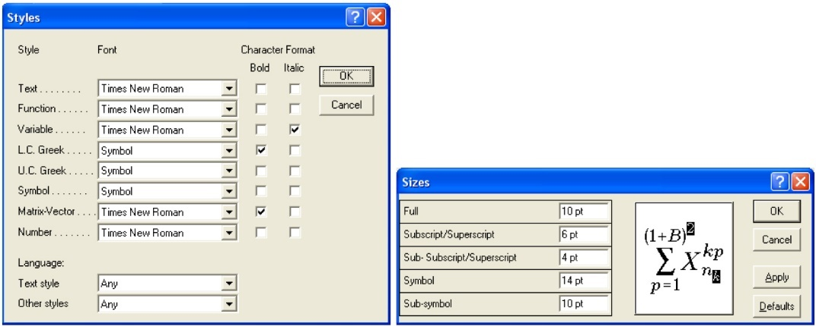
Fig. 1 Title of figure
An example of an equation written in Equation Editor:
$h_{ci}=\frac{q}{S(T_{wi}-T_{b})}$ (1)
Paragraph format for equations are (Style Equation): left indentation, 6 pt before and after, equation is at position of centered tab at 6.25 cm, number of equation is at position of right tab at 12.7 cm. Refer to equations in the text as Eq. (1), or Eqs. (1) and (2), and similar.
The file may be saved as .docx file. Equations must be editable, i.e. they cannot be given as figures.

1.2 Illustrations: figures, photographs, line drawings, graphs (Styles Figure and Figure Title)
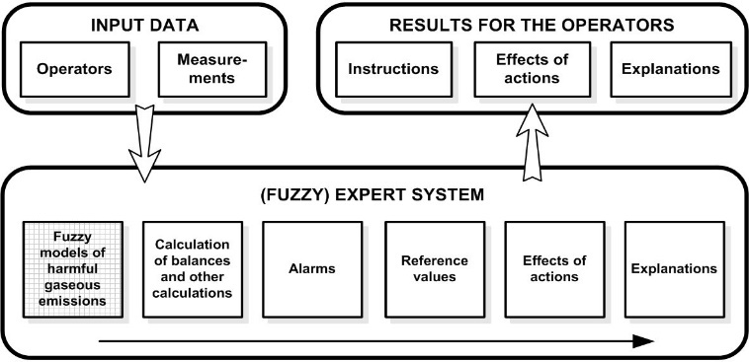
Fig. 2 Title of figure
All illustrations (figures, photographs, line drawings, graphs) should be numbered in series and all legends should be included at the bottom of each illustration. All figures, photographs, line drawings and graphs, prepared in electronic form, should be converted to TIFF or JPG (max quality) files, 300 dpi resolution. Figures, line drawings and graphs prepared using elements of MS Drawing or MS Graph must be converted in form of pictures and unchangeable. All illustrations should be planned in advance so as to allow reduction to 12.75 cm in column width. Please review all illustrations to ensure that they are readable. Refer to figures in the text as Fig. 1, or Figs. 1 and 2, and similar.

1.3 Tables
Table 1 Title of table (Style Table title)
System | Symbol
Without delay | +
Delay h = 1 | −
Delay h = N = 34 | *
All tables should be numbered with consecutive Arabic numbers. They should have descriptive captions at the top of each table and should be mentioned in the text.
Acknowledgement: The paper is a part of the research done within the project 1234567890. The authors would like to thank to the... (Style Acknowledgement).

References
(Samples for Serial, Book, Proceeding, Thesis, Report - Style Reference)
Blagojević, V., Milosavljević, Č., 2002, Application of digital sliding modes to synchronization of the work of two pneumatic cylinders, Facta Univesitatis Series Mechanical Engineering, 1(9), pp. 1275-1285.
Stojiljković, M., 2002, Logical synthesis of pneumatic control, Faculty of Mechanical Engineering, Niš, 376 p.
Muralidhara, H.S., 1998, Variable structure systems - A Survey, Proc. Sixth International Drying Symposium IDS 1988, Versailles, K1. 71.
Polat, O., 1989, Optimization of a Steam Boiler, PhD Thesis, McGill University, Canada, 413 p.
Perkin, R.M., 1999, Feature models in Virtual Product Development, Report ECRC/M1677, Capenhurst, England.
www.link.com (last access: dd.mm.yyyy)

Make sure all references are strictly formatted as per template, i.e. as per examples listed above. Reference elements (for instance, for a journal reference: authors, publication year, Paper title, Journal Title, volume(issue), pp. page-page) are separated by comma (do not use a dot). Do not use “et al.”, “and” or “&” in the list of authors. There should be no empty space between initials (check reference no. 3 above). Do not use capital letters where not appropriate (compare with the examples). The titles of journal references use small letters, and capital letters only where demanded by grammar. On the other hand, in the book tittles all the main words start with a capital letter, but not the connecting words. The indentations and the style of numbering must be the same as in the examples provided above. Refer to citations at a given order in the text by [1, 3, 5-7, 14] and similar.

